**CHAPTER 1**

**INTRODUCTION**

Water is one of the most essential elements of the survival of lives. About 70% of Earth’s surface is covered with water, yet the amount of freshwater ﬁt for human consumption and usage is as less as 2% of the total volume. With population growth increasing at tremendous rate, the human community has begun to face the wrath of water scarcity, only to be elevated by uncontrolled urbanization and industrialization which is further polluting the meager amount which is available for consumption. Presently, the quality and availability of freshwater resource are the most pressing of the many environmental challenges on the national horizon. Keeping these factors in mind, water conservation holds the topmost priority in today’s world. Also, monitoring the quality of water that is available to us for consumption is equally important as pollution has left no space for pure and potable water.

**1.1 SCOPE OF WORK**

Keeping these factors in mind, water conservation holds the topmost priority in today’s world. Also, monitoring the quality of water that is available to us for consumption is equally important as pollution has left no space for pure and potable water. This paper aims at designing a Smart Water Monitoring System (SWMS) for real-time water quality and usage monitoring. It consists of two parts: Smart Water Quantity meter and Smart Water Quality meter. The objective of designing Smart Water Quantity Meter is to ensure water conservation by monitoring the amount of water consumed by a household, notifying the same to the consumer and the authority.

A three-slab billing system generates consumption bill according to the quantity consumed. The Smart Water Quality meter checks the purity of portable water that the consumer receives, by measuring ﬁve qualitative parameters of water viz. pH, temperature, turbidity, dissolved oxygen and conductivity. The system ensures to prevent any health hazards or potential threats caused due to accidental seepage of sewage or farm release into the portable water. An online monitoring system is to provide these data on the cloud in real-time. Any violations in either the usage limit or water quality is immediately notiﬁed to the consumer and authority via SMS and an alert signal generated by the system.

**1.2 PREVIOUS WORK**

Several works have been done in the ﬁeld consumption is equally important as pollution has left no space for pure and potable water. Several works have been done in the ﬁeld of water quality analysis.

Tauﬁk Ibnu Salim et. Al. [1] has proposed a Portable and Online Water Quality Monitoring System using Wireless Sensor Network (WSN). The paper presents a measurement device to verify and monitor the water quality in a large area using wireless sensor network, and mainly focuses on monitoring and collecting data from the sensors node, storing the data into the PMS database, and displaying real-time and historical data.

Arjun K et. al. [2] has come up with an idea for Detection of Water Level, Quality, and Leakage using Raspberry Pi TM with the Internet of Things. Their proposed system relies on raspberry pi TM and sensors. The system measures the level, turbidity, pressure and pH and stores these measured values into the database, and based on the threshold values set, notiﬁcations are sent out to consumers and authorities.

Shuang-Hua Yang et.al.[3] has successfully designed, installed and tested IoT based remote, near real-time wireless household water consumption monitoring system in several households in Poland and Greece. In their paper Sajith Saseendran et. al.[4] have discussed about the design of an automated water usage monitoring system which proposes an effective way of controlling the wastage of water at home or industries by means of Wireless Sensor nodes and LabVIEW software. IoT is used to continuously monitor and track water usage via wireless sensor nodes and excess usage of water is immediately indicated and alert is sent to the user.

**1.3 PRESENT DEVELOPMENT**

In this paper, SWMS is designed with an objective to tackle both these real-life problems which is gravely affecting the quality of life that we live. Section II describes in detail our proposed system along with the ﬂowchart and algorithm. The hardware and software implementation of the SWMS is discussed in Section III. Section IV shows the various results obtained on implementing the system, followed by Section V on Conclusions and Future Work that can be carried out on the designed system.

**CHAPTER 2**

**PROPOSED SYSTEM**

As mentioned in Section I, the Smart Water Monitoring system proposed in this paper focuses on solving two of the major problems related to water distribution in today’s world, viz. Water Quality Checking and Water Usage Monitoring. The SWMS consists of two main parts: A smart water quantity meter which ensures water conservation by monitoring the amount of water consumed by a household, notifying the same to the consumer and the authority. This will lead to optimized amount of water consumed as the consumption charge increases with the increase in water usage. A three- slab billing system calculates the total bill for monthly water consumption based on three water limits as shown in Table II[6]. On crossing each of the three limits of water usage, the consumer is intimated via SMS and email notiﬁcations along with the detail of amount of water that has been consumed so far.The second part is a Smart water quality meter which checks the purity of drinking water that the consumer receives. It measures four qualitative parameters of water to determine its potability. The parameters that are considered by this system are pH, temperature, turbidity and conductivity. These parameter values are compared against standard allowable limits for drinking water as shown in Table I[5]. It prevents any health hazards or potential threats caused due to accidental seepage of sewage, farm release or any unwanted efﬂuent into the potable water supply lines.

**TABLE I**

**WATER QUALITY PHYSICAL PARAMETERS STANDARD VALUE TABLE**

|  |  |
| --- | --- |
| **Water quality**  **Parameter** | **Standard Value**  **Range(unit)** |
| pH | 6.5 8.5 |
| Turbidity | 6.0 10.0 (NTU) |
| Temperature | 20 30(0C) |
| Conductivity | 0.00 0.05 (mS/m) |

**TABLE II**

**EXISTING TARIFF SYSTEM V/S PROPOSED VOLUME BASED SLAB SYSTEM**

|  |  |  |
| --- | --- | --- |
| **Slab**  **(L)** | **Water Tariff**  **(Rs/KL)** | **Proposed Tariff**  **(Rs/KL)** |
| 0-8,000 (minimum) | 7.00 | 7.00 |
| 8,001-25,000 | 11.00 | 26.00 |
| 25,001-50,000 | 26.00 | 45.00 |
| 50,001-above | 45.00 | Termination of water supply  for that particular month |

An online monitoring system is used to provide remote access to the data generated by the monitoring system. The data, i.e. the water quality parameter values and the water consumed by the consumer for a given period of time, is updated periodically on the web portal which can be accessed by the consumer and the concerned authority at any instance of time. Once the water level crosses any of the three slabs, the consumer is notiﬁed who can then take measures to utilize water efﬁciently. Similarly, any deviation in the water quality is detected by the system, the consumer and the authority is notiﬁed via SMS and an email so that immediate action can be taken.

**2.1 FLOW CHART**

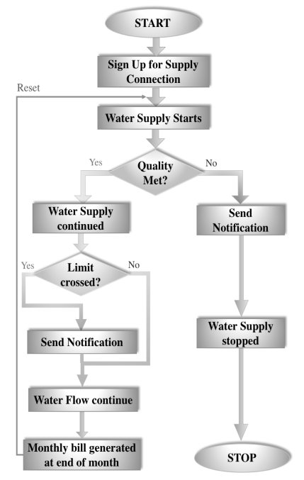

Figure 1: Flow Chart of Smart Water Monitoring System Flowchart

**2.2 ALGORITHM**

The ﬂowchart for the operation of SWMS is as shown in Fig. 1. The algorithm of operation based on the same is as follows:

• The three limits for water consumption are set by the main station.

• Once a user opts for a new water supply connection, a unique user ID is provided and the system is set up at the users household.

• The water supply to the household starts.

• At the entry point to the house, the quality of the water is checked.

• The Water Quality sensor nodes collect the parameter values and serially send it to the Raspberry PiTM.

• Based on the standard quality parameters, the Raspberry PiTM decides whether the water is portable and ﬁt for drinking or not.

• If the water is ﬁt for drinking, the water supply to the house continues.

• Based on the three slab system, the water consumption is checked. After each limit is crossed, a notiﬁcation is sent to the user as well as the authority mentioning the amount of water consumed from the start of the month till that point of time.

• The water ﬂow continues until another limit is crossed. For each of the three limits, the cycle repeats.

• At the end of the month, based on the proposed three-slab system, the total bill is generated.

• After the generation of the bill, the readings are reset and water supply for next month begins.

• In case the water is not ﬁt for drinking, a notiﬁcation is sent to the user and authority along with the physical parameter values of the water.

• The water supply is immediately stopped to prevent any accidental consumption of impure water, and the supply remains closed until the water quality issue is resolved[10].

**CHAPTER 3**

**IMPLEMENTATION**

The block diagram of the SWMS is as shown in Fig.2. The direction of arrow denotes the direction of ﬂow of data. Broadly, the system consists of a microprocessor which processes all the input data and based on them it takes decisions. Raspberry PiTM(RPi) acts as the microprocessor and the various sensors - pH sensor, Temperature sensor, Turbidity sensor and water ﬂow sensor act as input sources to the RPi. Based on the input data from these sensors, the RPi sends actuating signals to the Solenoid valve and LCD Display. The Solenoid valve acts as water ﬂow control mechanism. It allows the ﬂow of water when open, and terminates the supply when closed. LCD Display is used to display appropriate messages at different instances.

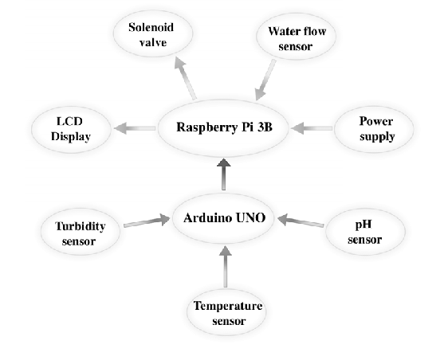

Figure 2: Block diagram of Water Monitoring System

**3.1 HARDWARE** **REQUIREMENTS**

1) **Raspberry PiTM:** The Raspberry PiTM(RPi) is a low cost single board computer with USB ports, Ethernet port, GPIO port, Micro SD card slot, audio port, HDMI port and Power provision. It is the most important component in the system. It takes sensor data as input and gives output to the valve and LCD. The water quality is determination and water consumption calculations are carried out by RPi, based on the standard quality value table and proposed slab tariff table as mentioned in Section III.

2) **Arduino UNOTM:** The sensors used for collecting water quality data are interfaced with Arduino UNOTM, which in turn is serially connected to RPi. The data obtained from these sensors are in Analog form. Thus these sensors require the use of Analog-to-Digital Converter (ADC) for direct interfacing with RPi. As an alternative to ADC, we have used Arduino UNOTM to simply the task, and leaving scope for further feature upscaling.

3) **Sensors**: Four sensors are employed in the implementation of SWMS. The pH sensor, Turbidity sensor and Temperature sensor[8-9] are used for collecting water quality data. The pH sensor gives the information of pH level of water sample, turbidity sensor measures the quantity of suspended particles and as the name suggest, temperature sensor measures the temperature of the water. Since the Electrical Conductivity(EC) water is closely related to the temperature of water, at near room temperature, the temperature sensor data is also used to measure conductivity of water.

Water ﬂow sensor is used to measure the amount of water consumed. It consists of a plastic valve body, a water rotor, and a hall-effect sensor. When water ﬂows through the rotor, rotor rolls. Its speed changes with different rate of ﬂow. The hall-effect sensor outputs the corresponding pulse signal. As water ﬂows through the sensor, the rotor rolls. The number of rotations of the rotor gives us the measure of amount of water that has ﬂown through the ﬂow sensor.

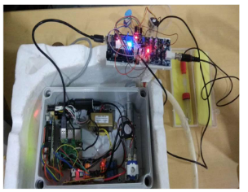

Figure 3: SWMS Hardware Implementation

**3.2 SOFTWARE** **REQUIREMENTS**

A web portal is designed for real-time remote monitoring of the SWMS system. The water quality data is periodically updated on the portal, with graphical representations demonstration the safety level of water based on the individual physical parameter of water.The water utilization data is also updated periodically. A graphical representation showing the consumption in last 12 hours (can be changed according to our need) is helpful in giving an overview of the total water utilization throughout the day. It also shows the total water utilization since the starting of the month, and the corresponding bill calculated based on the proposed three slabs.

**CHAPTER 4**

**RESULT** **ANALYSIS**

The SWMS is successfully implemented as shown in Fig. 3. The output of the system against a Pure water sample is shown in Fig. 4. The physical parameter values for the water sample and the result, i.e. whether water is Pure or Impure based on these four parameters, are displayed on Terminal. When the water passes the quality test, supply continues and the three usage limits are displayed followed by the water consumption reading.

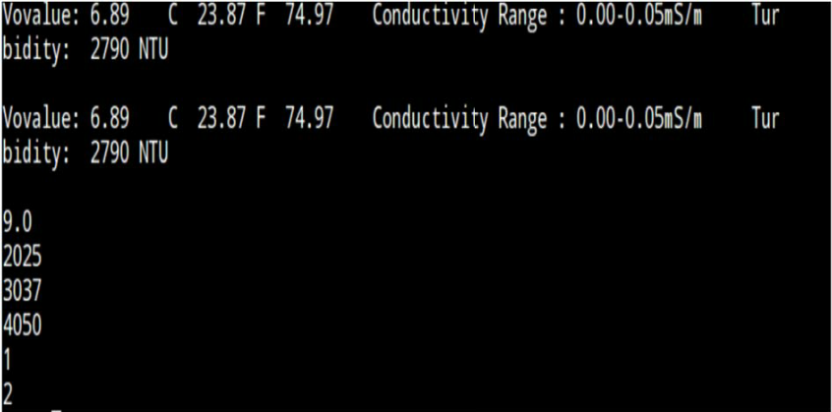

Figure 4: SWMS output sample

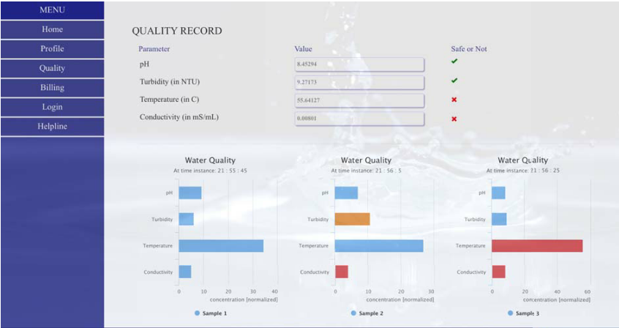

Figure 5: SWMS Quality Check window showing water with desired Quality

Fig. 5 and Fig. 6 show the web portal where the real-time water quality parameters and the water consumption readings are updated. In Fig. 5 , the graphical representations of the parameters are shown. The bar graphs represent the quality status of three different water samples, in terms of their parameters.

• Blue bar: Allowable/desired parameter value

• Orange bar: ± 10% deviation in the desired value

• Red = >± 10% deviation in desired value

Sample 1 thus represents water with all its four parameters within the potable water range and can be used for drinking purpose. Sample 2 water has a turbidity slightly more/less than the allowable range, but conductivity beyond the considerable limit. Hence water supply will be terminated. Similarly, water in Sample 3 has a temperature and conductivity beyond the standard range.

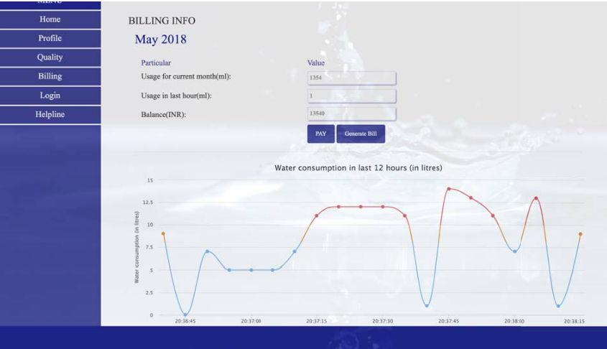

Figure 6: SWMS Billing window showing hourly water usage

Fig.6 shows the plot of water consumption in the past hours of the day. Consumption above an average threshold value is highlighted in orange-¿red for visual interpretation purposes. The cumulative water usage since the beginning of the month along with the tentative bill, calculated according to the proposed slab, is updated in real-time for the customers.

**CHAPTER 5**

**CONCLUSION AND FUTURE WORK**

The Smart water quality check meter is automatic and does not require much human interference, thereby reducing the errors. The real-time monitoring provides immediate remote access to the water quality as well as quantity data for any household. All these measures aims at bringing down the unnecessary usage of water and prevention of health hazards caused due to consumption of impure water. The usage of individual sensors for each parameter adds to the cost of the system. Using a single sensor for analyzing multiple parameters can help reduce the cost. Further work on developing an integrated sensor system which can monitor all the physical parameters of water to analyze its quality at least cost can be carried out. Latest advancements in computation, as Machine Learning and/or AI algorithms can be applied to make a decision about Water quality These techniques can also be used to predict the water usage for individual users, based on their previous data.

**REFERENCES**

[1] Tauﬁk Ibnu Salim, Hilman S. Alam and Rian P. Pratama, Portable and online water quality monitoring system using wireless sensor network, 2nd International conference IEEE ICACOMIT 2017, Accession num- ber: 17487078, January 2018.

[2] Arjun K, Latha C A, and Prithviraj, Detection of Water Level, Quality and Leakage using Raspberry Pi with Internet of Things, International Research Journal of Engineering and Technology (IRJET), Volume 04 Issue 06, June 2017, pp 2875-2880.

[3] Shuang-Hua Yang, Xi Chen et.al., ”A case study of Internet of things: A wireless household water consumption monitoring system”, 2015 IEEE 2nd World Forum on Internet of Things (WF-IoT), Accession Number: 15729217, December 2015

[4] Sajith Saseendran and V. Nithya, Automated Water Usage Monitoring System, 2016 IEEE International Conference on Communication and Signal Processing, April 6-8, 2016.

[5] http://www.groundwatertnpwd.org.in/wqlab2.htm

[6] https://bwssb.gov.in/content/prorata-and-water-tariff

[7] Theofanis P. Lambrou, Christos C. Anastasiou, Christos G. Panayiotou, and Marios M. Polycarpou, A Low-Cost Sensor Network for Real-Time Monitoring and Contamination Detection in Drinking Water Distribution Systems, IEEE sensors journal, Volume 14, No. 8, August 2014, pp 2765-2772.

[8] Brinda Das and P.C. Jain, Real-Time Water Quality Monitoring System using Internet of Things, 2017 IEEE International Conference on Com- puter, Communications and Electronics (Comptelix), July 01-02, 2017.

[9] A. N. Prasad, K. A. Mamun and F. R. Islam, Smart water quality monitoring system, 2nd IEEE APWC on CSE 2015, Accession number: 16005040, May 2016.

[10] N.Suresh , E.Balaji , K.JeffryAnto , J.Jenith Sathyabama Raspberry pi based liquid ﬂow monitoring and control Sathyabama University, Tamil Nadu, India, Volume: 03 Issue: 07 Jul-2014.